Advanced Options
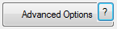
The program has all the initials on the main window for you to use on a daily bases. Though, if you desire to add more customizations to your clock, you'll have to press the Advanced Options button. There is a lot to cover, and therefore it will be broken into parts. The Advanced Options window is broken up into tabs, so we'll group it as such.
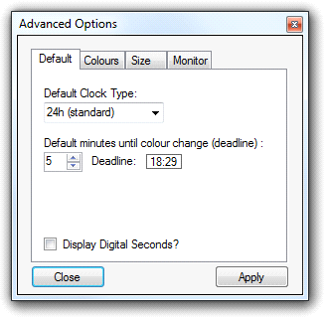
It’s built up of 4 tabs:
- Default: where you can manage all of the default configurations
- Colours: Where you can set the layout customization, such as colours and analogue layout
- Size: Where you can change the size of the clock window
- Monitor: Where you can set what monitor the clock window is to be displayed on if it’s in full screen

None of the changes you do in the advanced option window will take effect until you press the apply button.

Default
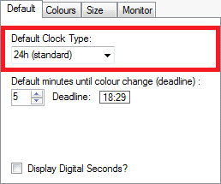
The Default Clock Type is what the Default Pre-set will be using. You can read about pre-sets in More Advanced.
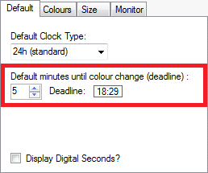
This lets you set the default value of the x minutes until the time is equal to the deadline. The value can always be altered upon in the main window, but this will just set the default value. Meaning, that this value, will always be displayed when you turn on the program. You can read about deadlines in Display Deadline.
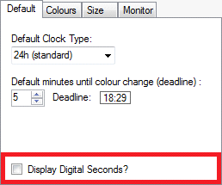
This will determine if the clock will display the seconds or not. This checkbox is an exception to the Default tab, as this value can be added to a Pre-set. You can read about Pre-sets in More Advanced.

Colours
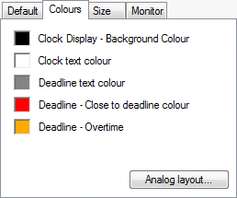
The Colours tab has 3 features.
- You can set the colours of the digital clock
- You can set the universal deadline colour properties (Close to deadline and Overtime), for both the digital and the analogue clock types.
- You can create your own custom Analogue Clock Layout. You can read more about this in Analogue Clock Layout Customization
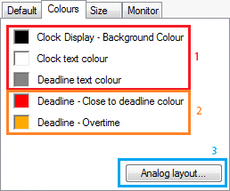
These values can be added to your Pre-set. So if you change any of the settings, you can apply it to your own custom pre-sets for later use. This applies to all the 3 features. You can read about pre-sets in More Advanced.

Size
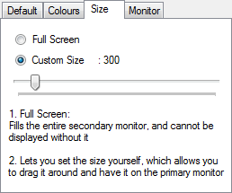
The size tab is used for managing the clock window size. The size tab actually has its own little instructions beneath the controllers.
Basically, Full Screen allows you to fill whatever secondary monitor that there may be with the clock window, making it automatically a full screen window. Keep in mind that doing so, will revoke your ability to drag the clock window around and also, this will require at least two monitors. If at least two monitors are present (the primary one and some sort of external monitor), the clock window will now be displayed. Also note that you can never display the clock window on the primary monitor (the one with the taskbar at the bottom of the screen) while it’s in Full Screen mode.
Custom Size lets you decide the clock window size by dragging the slider horizontally. Setting it to custom size will allow you to drag the clock window around.

Monitors
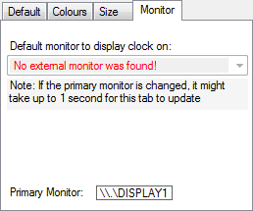
The monitor tab gives you the ability to see all the monitors currently hooked up to the computer. The primary one is being displayed at the bottom for convenience, while all the others are being displayed in the dropdown box at the top.
The dropdown box allows you to pick what external monitor you wish to automatically display the clock window on, when it’s set to Full Screen. If there is no external monitor to be found, you’ll receive an error message that says, “No external monitor was found!” As shown in the picture above.
To fully understand the Full Screen, please look to the Size section of this help report.
This is being updated live; both the monitor selection as well as changing the primary monitor.

As stated before, any changes you may have done in the advanced options window will not affect the program until you press the apply button. So if something goes horribly wrong, just close the window and open it again and you’ll see all the settings are set to the same as when you opened it.

